Name: Eliseo V. Camilon Jr.

Student ID: 1203383436

Date: 05/02/17

**Instructions:** Congratulations, you made it to the end of the course! You should have at least seven pages of your site completed by the time you submit this. Use the following to have a written discussion about your experience in the course and the final project.

**Before submitting this document and all of your project files, make sure you meet all of these requirements:**

* You have complete the “Final Submission and Discussion” worksheet.
* You have zipped up or compressed your final project folder (including all of your HTML, CSS, images, videos, etc.)
* All the requirements listed in the CIS300 Project Instructions.pdf file.
* Make sure you include all the required screenshots listed in this file. 2 points will be taken off for each missing screenshot.

**Discussion Questions**

1. **Now that you are finished with your project, your original concept of your project might have changed a lot. Discuss in detail the differences between your initial project design and your final product. Why did you make these changes (if you had any)?**  
     
   I originally had twelve pages, but I did not like the idea of having too many pages and too many information. I think too much information and pages and links makes the user not want to explore your website. I reduced the webpage count to the minimum amount. I did not deviate from the original project plan and wireframe, other than reducing the amount of pages and links.
2. **Describe in detail why you chose the design layout you did. Are you happy with the outcome? Did you run into any issues with your design while developing your site? What did you do to overcome those issues? Would you do anything differently the next time you designed a website?**   
     
   I wanted to embed soundcloud into my page from a website called soundcloud.com, but the use iframe to embed. So instead, I included my mp3 files for my songs instead. If I can expand this website, the cost could add up because of all those file sizes that would add up to host a lot of mp3 files instead of embedding them, and another website hosts it.
3. **You likely encountered challenges while working on your final project. In detail, describe the challenges you encountered and what you did to overcome them.**   
     
   I did not have a lot of challenges working with the website, I did however wanted specific sections of the webpage to appear when an href link is clicked, I figured out that you can include the id of a specific section you want to make it go to that webpage’s specific part. I also included jQuery commands to animate the scrolling when you press a llink. In addition, another mild issue I had was styling the contents, aligning them, and centering them – I worked around this by using live reload, which allows you to edit the website and instantly see the changes you are doing, that way I can test code. Spent a lot of time styling the icons and my resume page to look amazing.
4. **Describe several concepts that you learned during this course that you found interesting and useful. Where there any concepts that you wish more time was spent on? Is there anything you would have like to incorporate into your final project that wasn’t covered during this course?**  
     
   Although the course core concepts does not include Javascript and it is outside the scope of the class, I wish we did more php and data processing such as javascript and styling elements such as jQuery.
5. **OPTIONAL (NOT REQUIRED FOR THE CLASS OR FACTORED INTO YOUR GRADE): If you took advantage of the “Getting Online” video in the Week 6 / Chapter 12 folder and setup a domain and hosting, what were your thoughts on the process? Did you run into any issues? What domain did you pick? Did you upload your files? You may have already answered this in the update #2, but some students wait until the end to complete this.**
6. **While trying to be as objective and unbiased as possible, please go through and critique your own site using the attached rubric. In the student critique column, indicate which score you should receive for each category (outstanding, average, or needs improvement) and write a short (1 or two sentence max) justification of that score.**

**Student Critique**

|  |  |  |  |  |
| --- | --- | --- | --- | --- |
|  | **Outstanding** | **Average** | **Needs Improvement** | **Student Critique** |
| **EXAMPLE** | You did everything! | You did a few things. | You did nothing… | Outstanding – I believe I did everything correctly because of x, y, and z. |
| **Discussion Questions 1-4: Answers** | Clearly and completely answered the questions. Organized, neat in appearance, easy to read and understand |  |  | Outstanding, I believe I did everything correctly because the code is readable and well commented. |
| **Discussion Question 6: Mechanics** | Clearly and completely answered the questions. Organized, neat in appearance, easy to read and understand. |  |  | Outstanding, I believe I did everything correctly because the website is neat and easy to navigate |
| **Visual Appeal**  **appealing to target audience** | 1. Use of color, contrast, text, and graphics. 2. Navigation is consistent. 3. Page titles and logo are descriptive. 4. E-mail link is presented. |  |  | Outstanding, I believe I did everything correctly because the website is beautiful. :p |
| **Accessibility and Validation** | W3C Guidelines followed; numbers of web pages; validated external CSS file |  |  | Outstanding, I believe I did everything correctly because I use WebStorm integrated development environment that checks for errors in my code. |
| **Table** | Present and correct syntax | -- |  | Outstanding, I believe I did everything correctly because the table was implemented properly and correct syntax was used. |
| **Video** | Present and correct syntax, <video> tag is used | -- |  | Outstanding, I believe I did everything correctly because the website included a video in the design page of my website. |
| **Outside Link** | Present and correct syntax | -- |  | I have included the external link in the nav menu which should redirect to the link. |
| **Meta tag** | Correct syntax (description meta tags), excellent selection of keywords and meaningful description |  |  | Outstanding, I believe I did everything correctly in terms of meta tag because I used an IDE that has code snippets to implement meta tags with shortcut buttons. |
| **Form Coding and Processing** | Contains 4 or more form fields, correct syntax, and meaningful form element names. Use # or the pacific.php as the action |  |  | I used the # on my contact form and implemented JQuery to animate certain scrolling features. |

**Screenshot of Home Page**

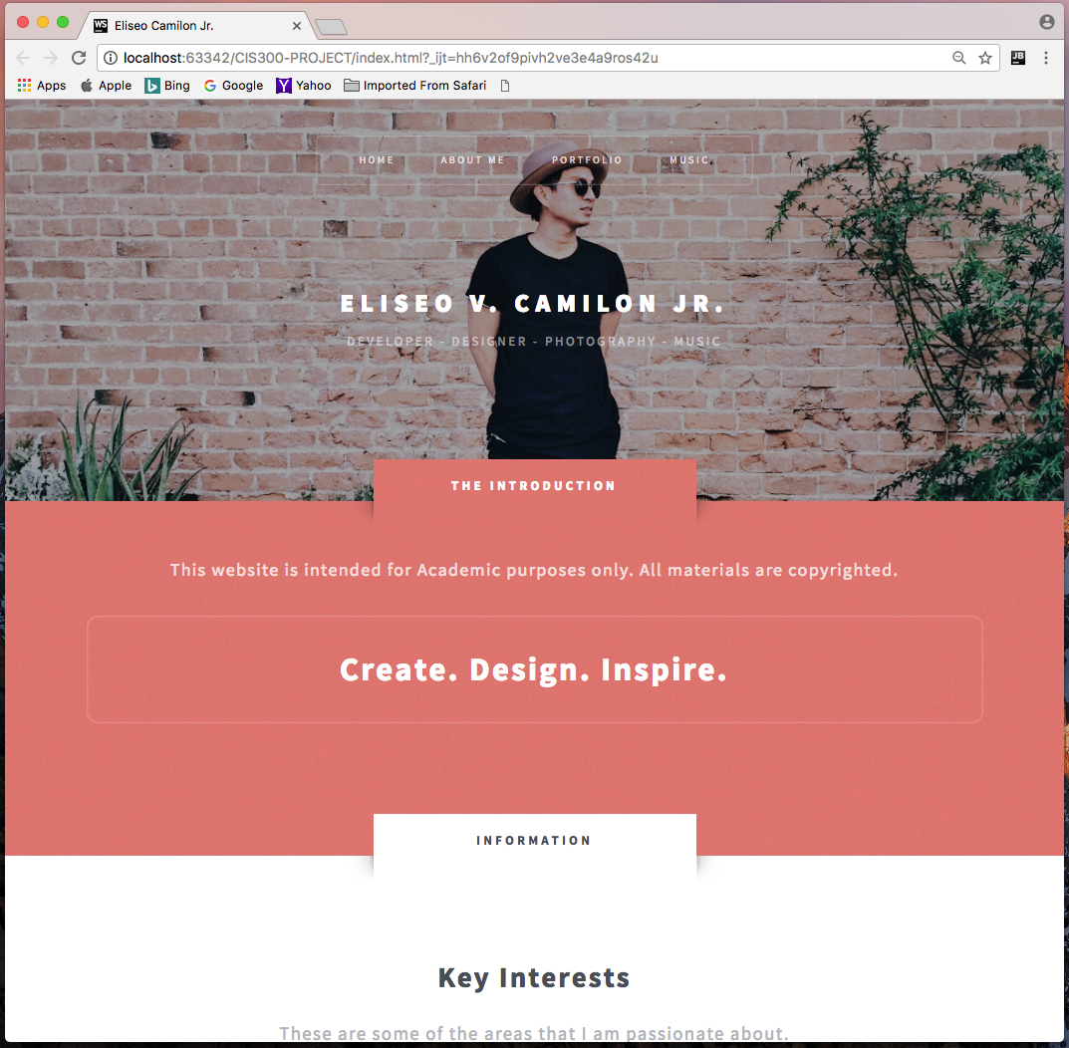

**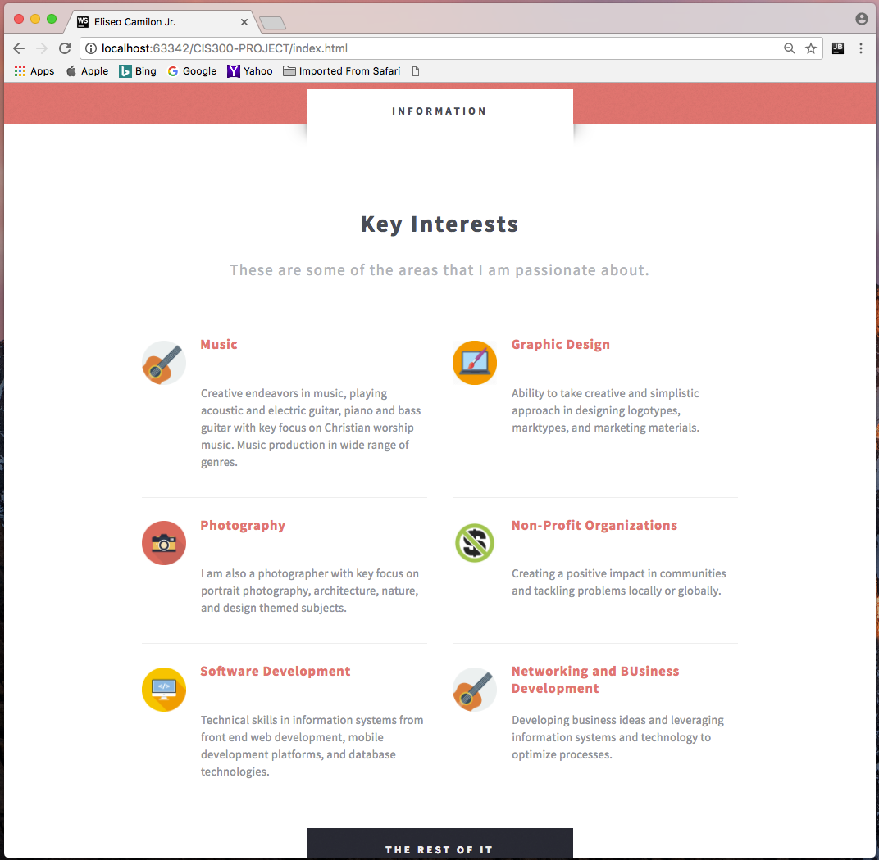  
Screenshot of Page #1  
Screenshot of Page #2**

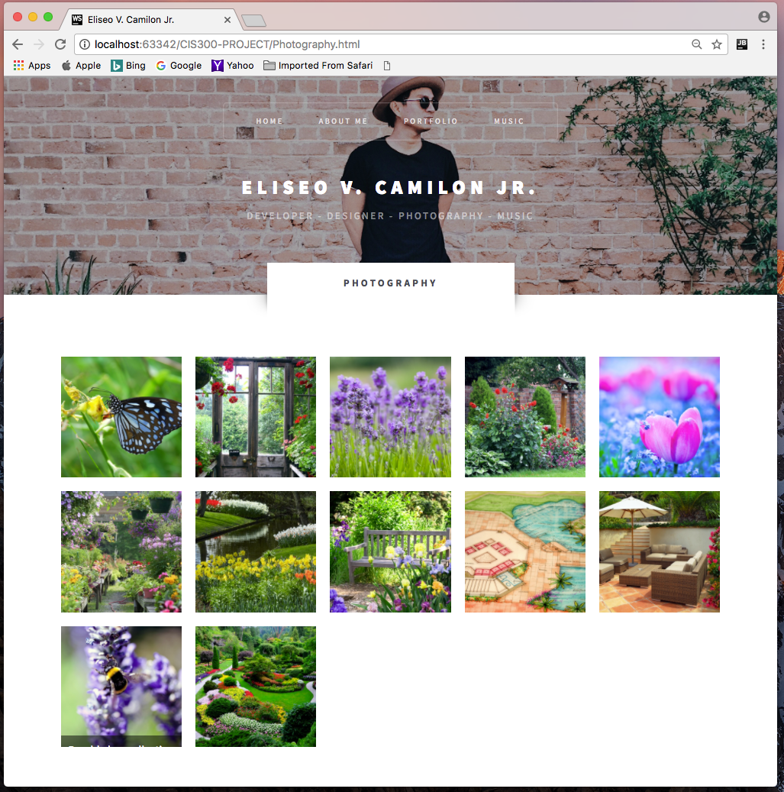

**Screenshot of Page #3**

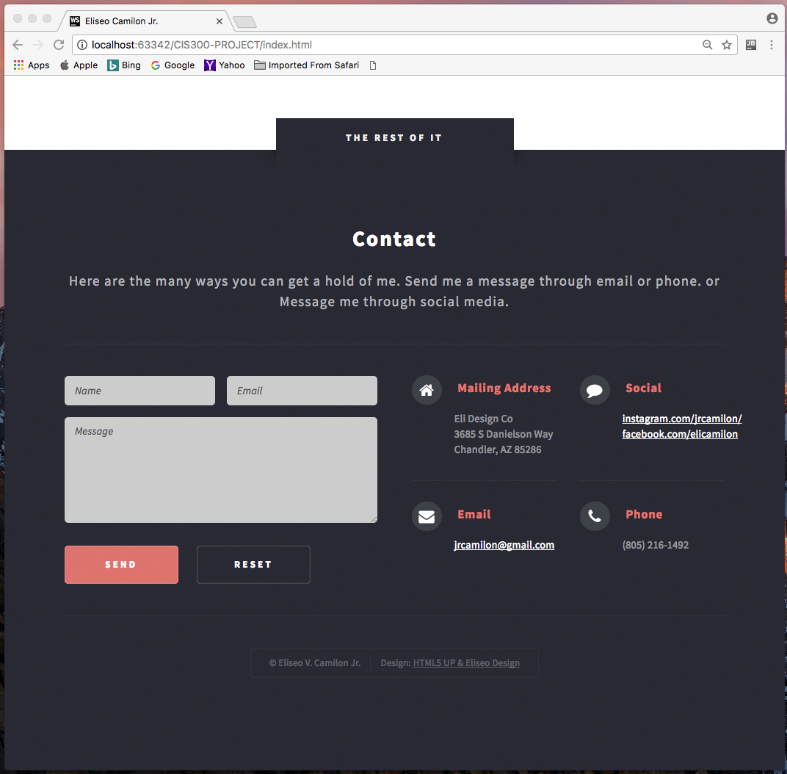

**Screenshot of Page #4**

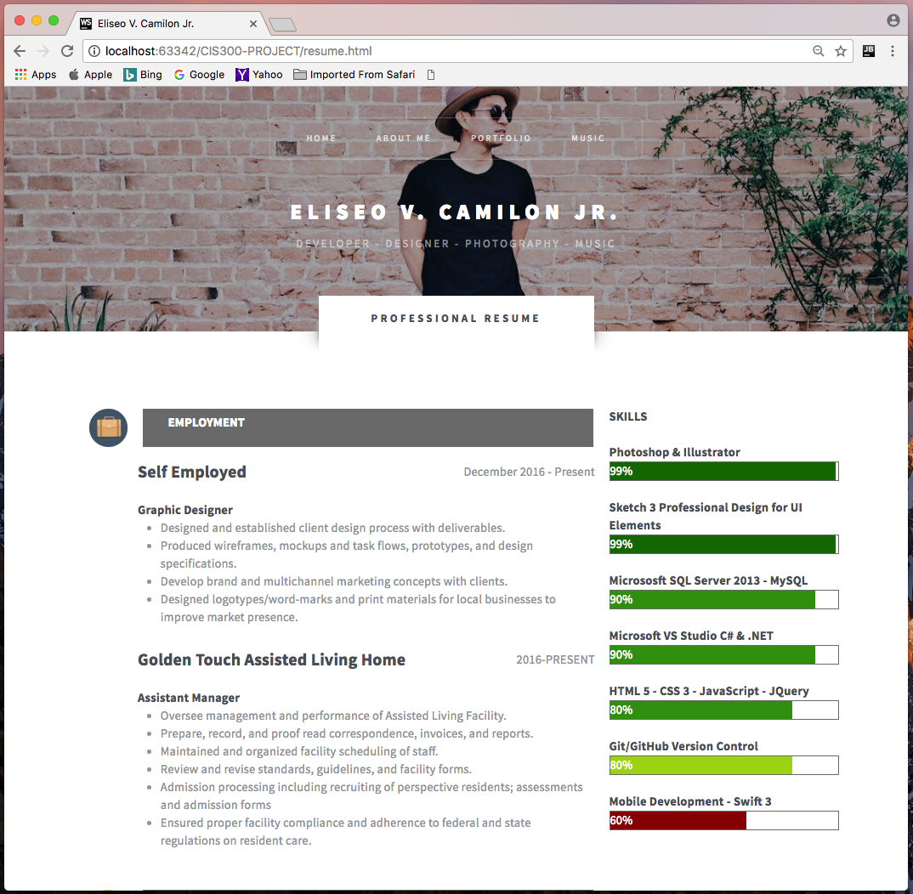

**Screenshot of Page #5**



**Screenshot of Page #6**

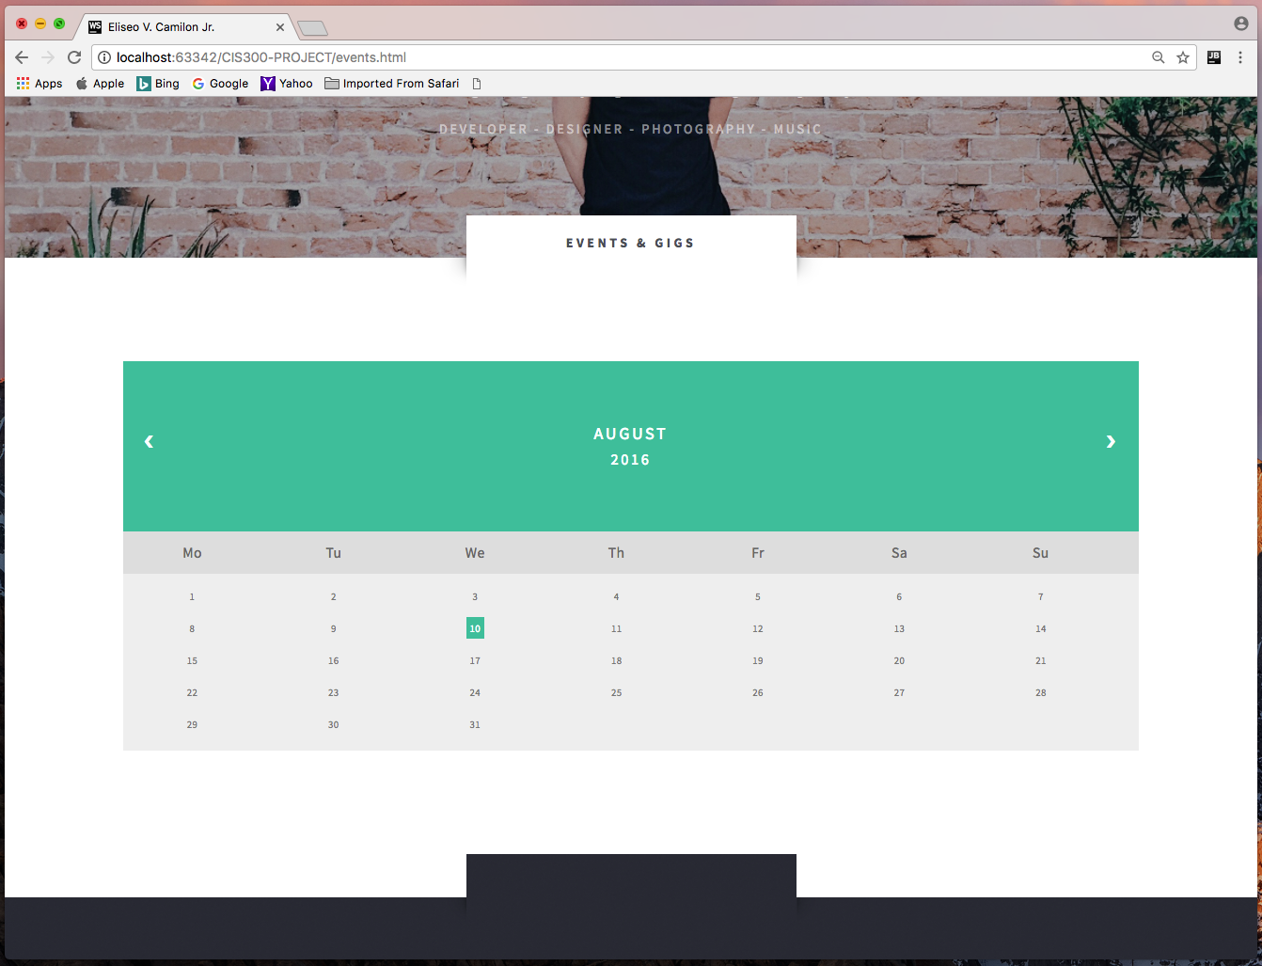

**Screenshot of location you used a table**

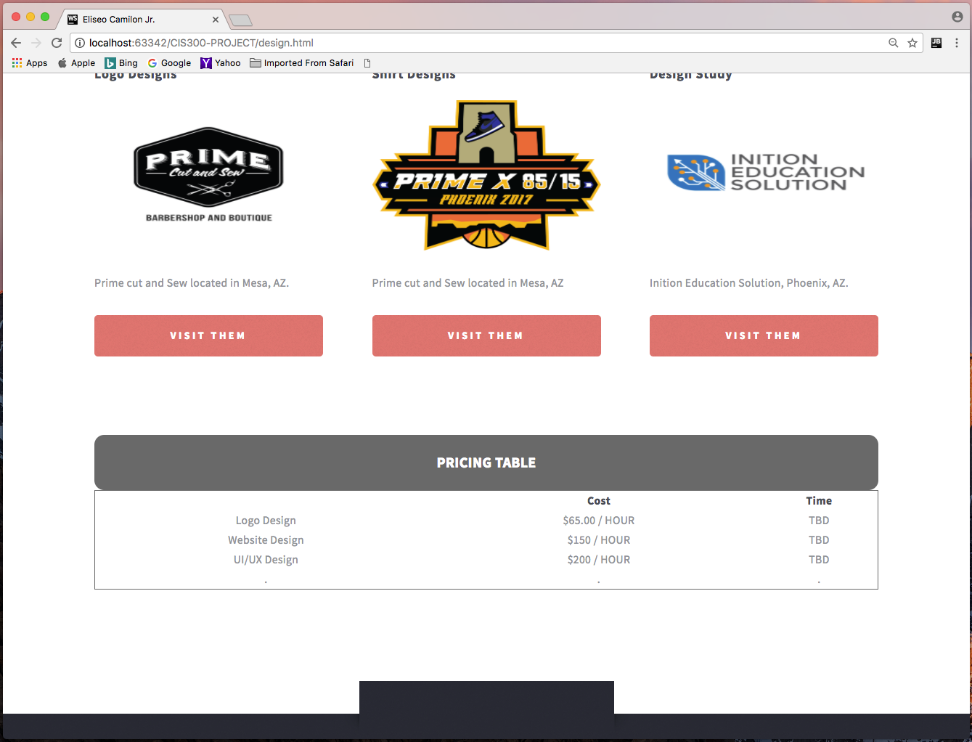

**Screenshot of where you used the <video> tag**



**Screenshot of where you used an e-mail link**



**Screenshot of where you used an external link**



**Screenshot of your form**



